Project Design Phase-II

Data Flow Diagram & User Stories

Date | 01 October 2026
Team ID | SWTID-2026-2085
Project Name | Import Data using Transform maps(spreadsheet)
Maximum Marks | 4 Marks

Data Flow Diagrams:

A Data Flow Diagram (DFD) is a traditional visual representation of the information flows within a system. For importing data using Transform Maps (spreadsheet), a neat and clear DFD shows the right amount of the import requirement graphically. It shows how spreadsheet data enters ServiceNow, what changes the information (loading it into an Import Set table, then applying the Transform Map's field mappings and Coalesce rules), where the data is stored (the Import Set table and the target table), and how the results leave the system (Transform History and the Import Log).

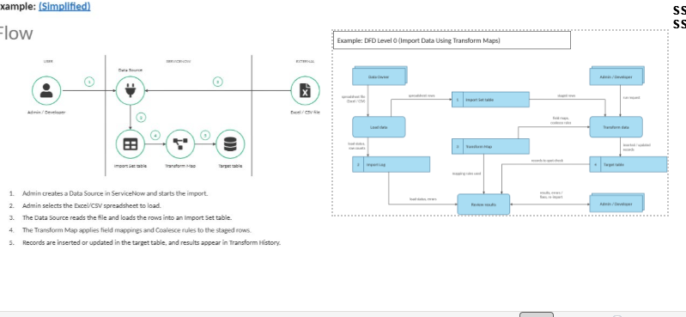

User Stories

Use the template below to list all the user stories for the product: Import Data Using Transform Maps (Spreadsheet).

